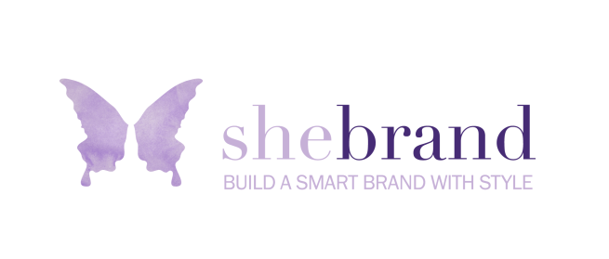

ULTIMATE BRAND CLARITY 2018

Set a timer for 30 minutes and answer the following questions as quickly as you can – without stopping to think too much or edit. Just write or type the first thing that comes to mind. There may be some redundancy, but that’s part of the process.

What are three words that best describe your brand?

What does your brand stand for?

What is the most important message you want your audience to know/learn?

If you were the invisible woman and could eavesdrop on someone speaking positively to another about your brand, what would they say? (3-4 sentences max)

Who do you serve? Who is your target audience?

What does your audience want most out of life?

What value do you provide your clients?

HOW do you do it?

WHY do you do it?

What do you want to be MOST known for?

If I were to ask someone who knows you well (best friend, sibling, significant other, etc.) what are one or two of your most striking gifts, how would they respond?

What is your brand’s personality? (i.e. lighthearted, accessible, quirky, etc.)

List three brands that inspire you (at least one or more should be outside your industry)

Of the three brands you listed above, what are the main qualities/attributes that you admire most about each one?

What are three things you can do in 2018 to step into a more powerful representation of your brand?

